**Assignment 1**

**Student Name:** Sahil Kaundal **UID:** 21BCS8197

**Branch:** BE CSE (Lateral Entry) **Section/Group:** 807/B

**Semester:** 4th **Date of Performance:** 24/03/2022

**Subject Name:** MPI **Subject Code:** 20CSP-252

**Q1.**

Write Assembly language instructions to:

1) Loading value in accumulator from location 3000H

2) Moving the value to register C

3) Loading the value in Register B from location 3001H

4) Swapping the contents of register B and C

5) Store the value in register C after swapping at 3002H

**Answer:**

* **Loading value in accumulator from location 3000H**

LDA 3000H

* **Moving the value to register C**

MOV C,A

* **Loading the value in Register B from location 3001H**

LDA 3001H

MOV B,A

* **Swapping the contents of register B and C**

MOV D, B

MOV B, C

MOV C, D

* **Store the value in register C after swapping at 3002H**

LDA 3002H

MOV A, C

STA 3002H

**Code:**

LDA 3000H

MOV C, A

LDA 3001H

MOV B, A

MOV D, B

MOV B, C

MOV C, D

LDA 3002H

MOV A, C

STA 3002H

HLT

**Output:**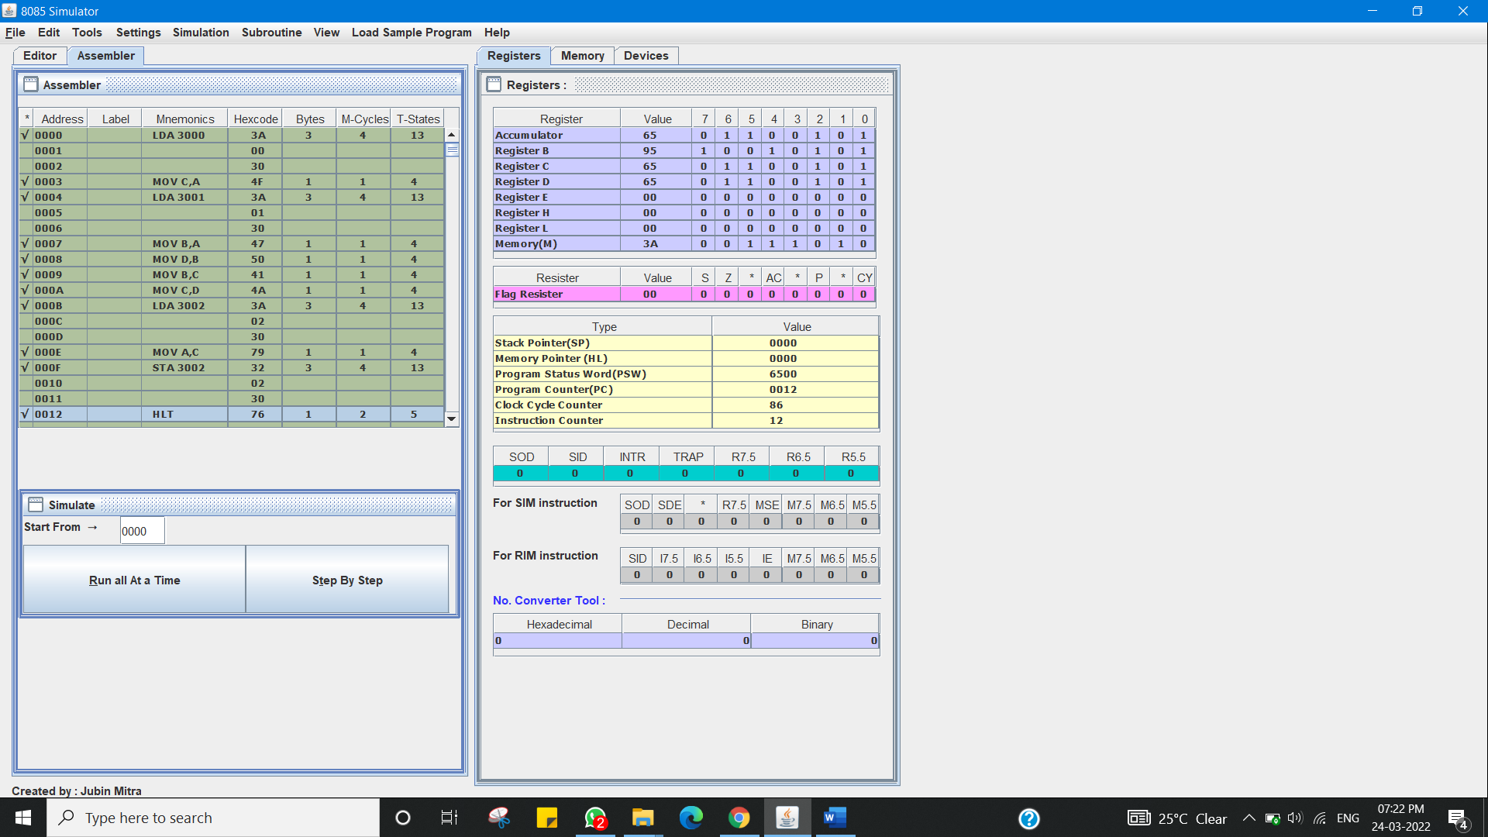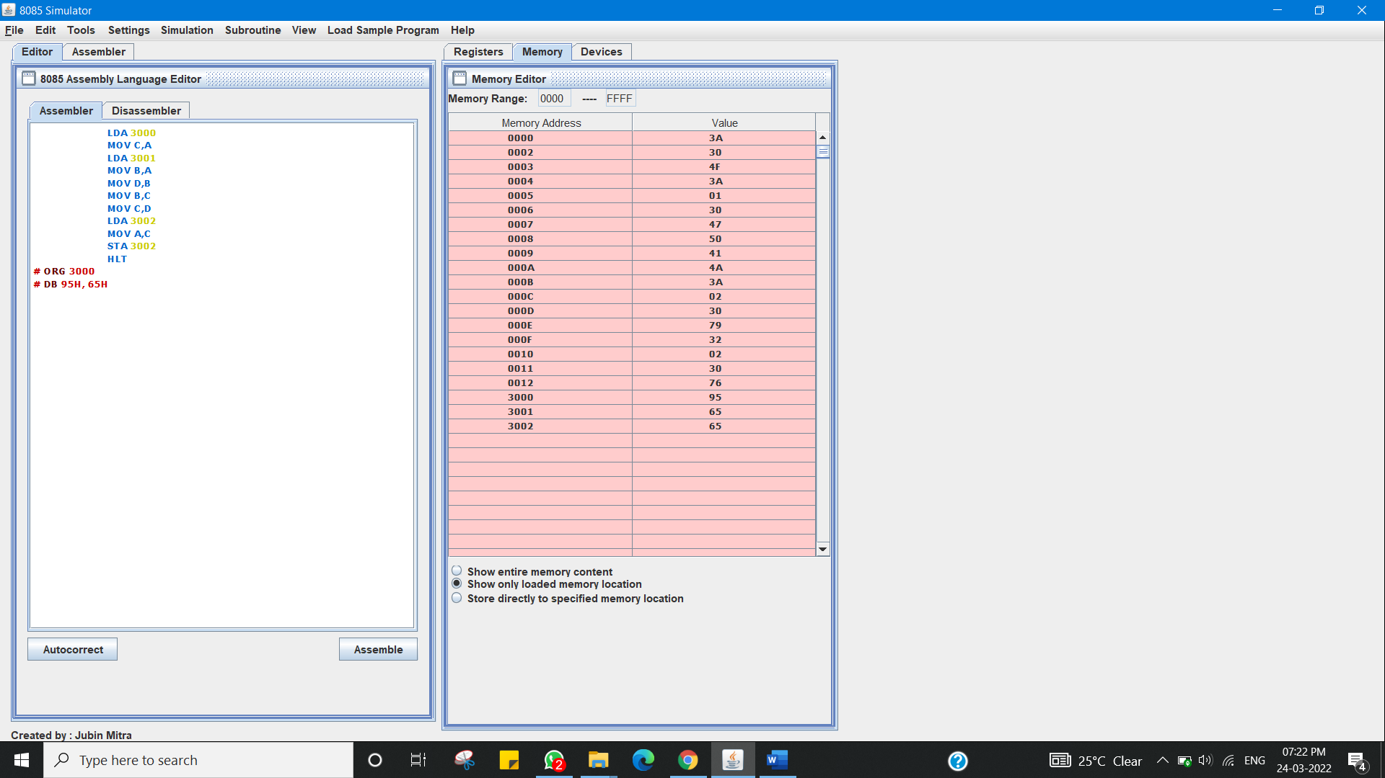

**Q2.**

Specify the contents of flag register for the following program:

MVIA,08H

MVIC,09H

SUBC

CMPC

HLT

**Answer:**

**Flag register in 8085 microprocessor**

The **Flag register** is a Special Purpose Register. Depending upon the value of result after any arithmetic and logical operation the flag bits become set (1) or reset (0). In 8085 microprocessor, flag register consists of 8 bits and only 5 of them are useful.

The 5 flags are:

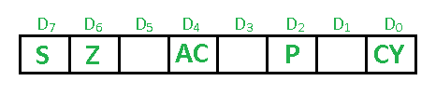

1. **Sign Flag (S) –** After any operation if the MSB (B(7)) of the result is 1, it indicates the number is negative and the sign flag becomes set, i.e. 1. If the MSB is 0, it indicates the number is positive and the sign flag becomes reset i.e. 0.  
   from 00H to 7F, sign flag is 0  
   from 80H to FF, sign flag is 1

1- MSB is 1 (negative)  
0- MSB is 0 (positive)

**Example:**

MVI A 08 (load 08H in register A)  
MVI C 09 (load 09H in register C)  
SUB C (A = A – C)

CMP C  
These set of instructions will set the sign flag to 1 as 08 – 09 is a negative number.

1. **Zero Flag (Z) –** After any arithmetical or logical operation if the result is 0 (00)H, the zero flag becomes set i.e. 1, otherwise it becomes reset i.e. 0.  
   00H zero flag is 1.  
   from 01H to FFH zero flag is 0
   1. zero result  
      0- non-zero result
2. **Auxiliary Carry Flag (AC) –** This flag is used in BCD number system(0-9). If after any arithmetic or logical operation D(3) generates any carry and passes on to B(4) this flag becomes set i.e. 1, otherwise it becomes reset i.e. 0. This is the only flag register which is not accessible by the programmer

1-carry out from bit 3 on addition or borrow into bit 3 on subtraction  
0-otherwise

1. **Parity Flag (P) –** If after any arithmetic or logical operation the result has even parity, an even number of 1 bits, the parity register becomes set i.e. 1, otherwise it becomes reset i.e. 0.

1-accumulator has even number of 1 bits  
0-accumulator has odd parity

1. **Carry Flag (CY) –** Carry is generated when performing n bit operations and the result is more than n bits, then this flag becomes set i.e. 1, otherwise it becomes reset i.e. 0.  
   During subtraction (A-B), if A>B it becomes reset and if (A<B) it becomes set.  
   Carry flag is also called borrow flag.

1-carry out from MSB bit on addition or borrow into MSB bit on subtraction  
0-no carry out or borrow into MSB bit

**Code:**

MVI A,08

MVI C,09

SUB C

CMP C

HLT

Contents of flag register:

SIGN FLAG = 1

ZERO FLAG = 0

AUX. CARRY = 1

PARITY FLAG =1

CARRY = 0 As no carry generated

**Output:**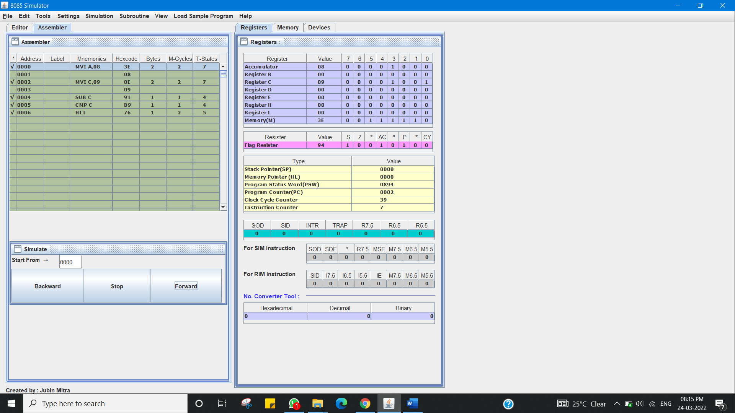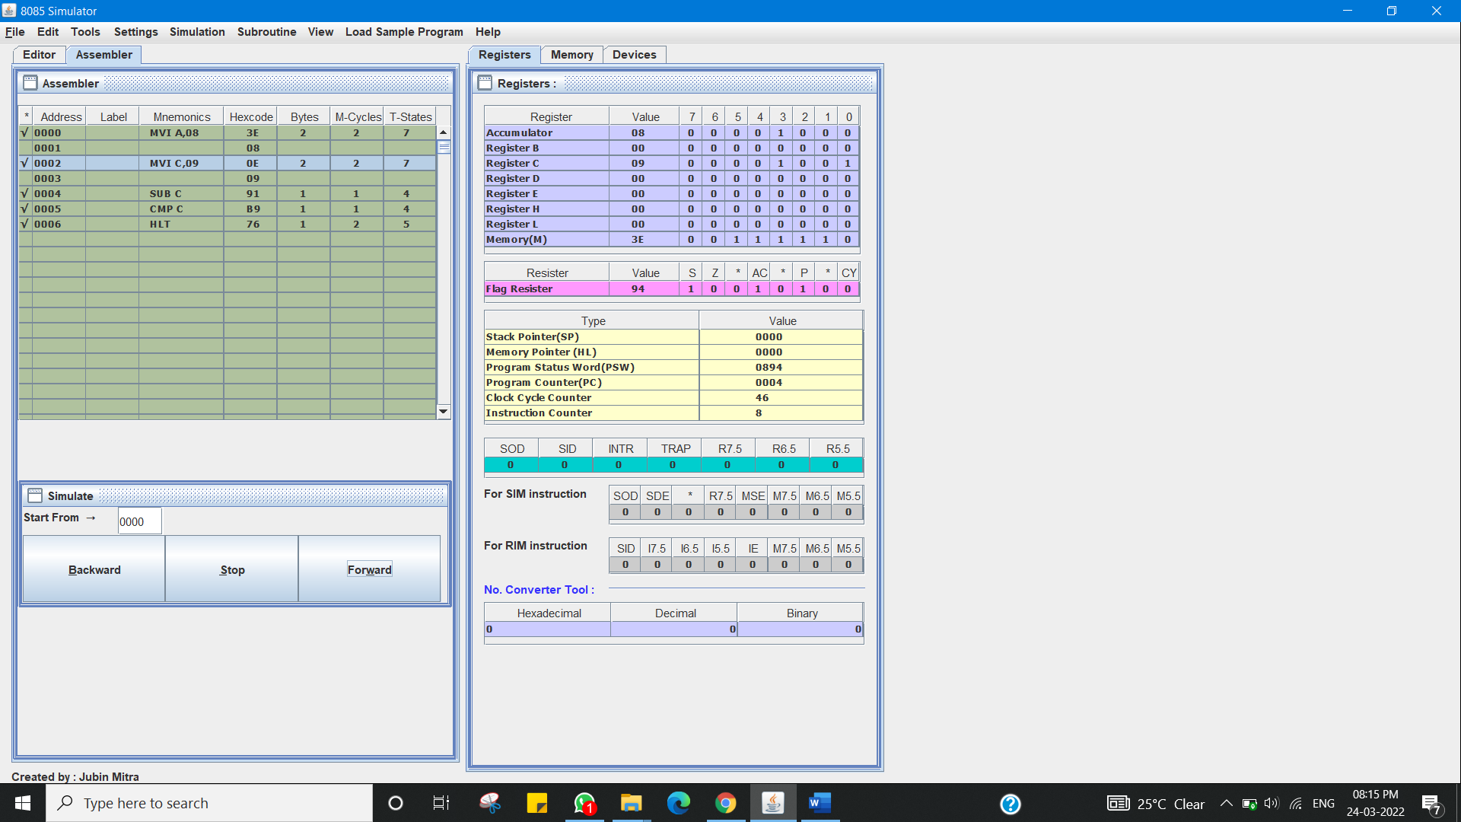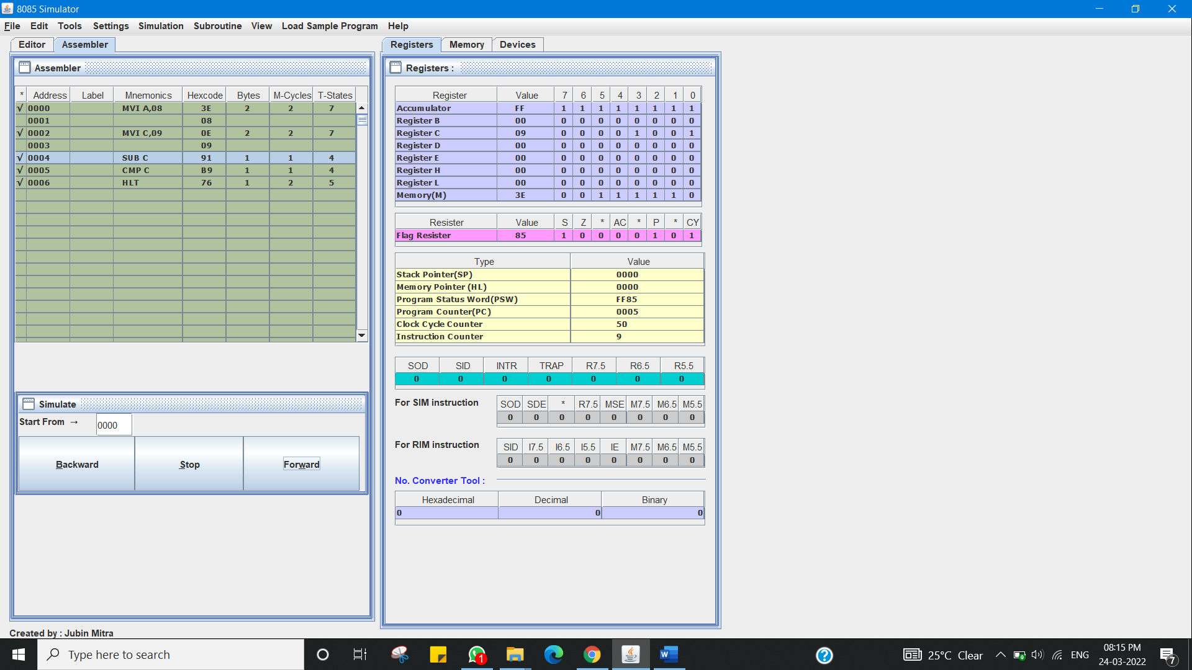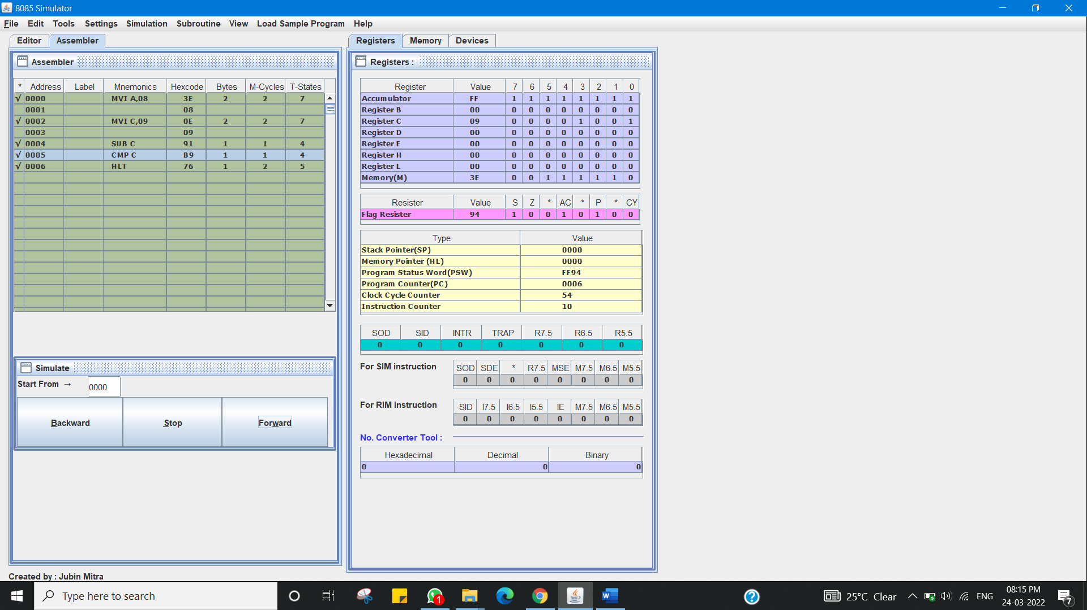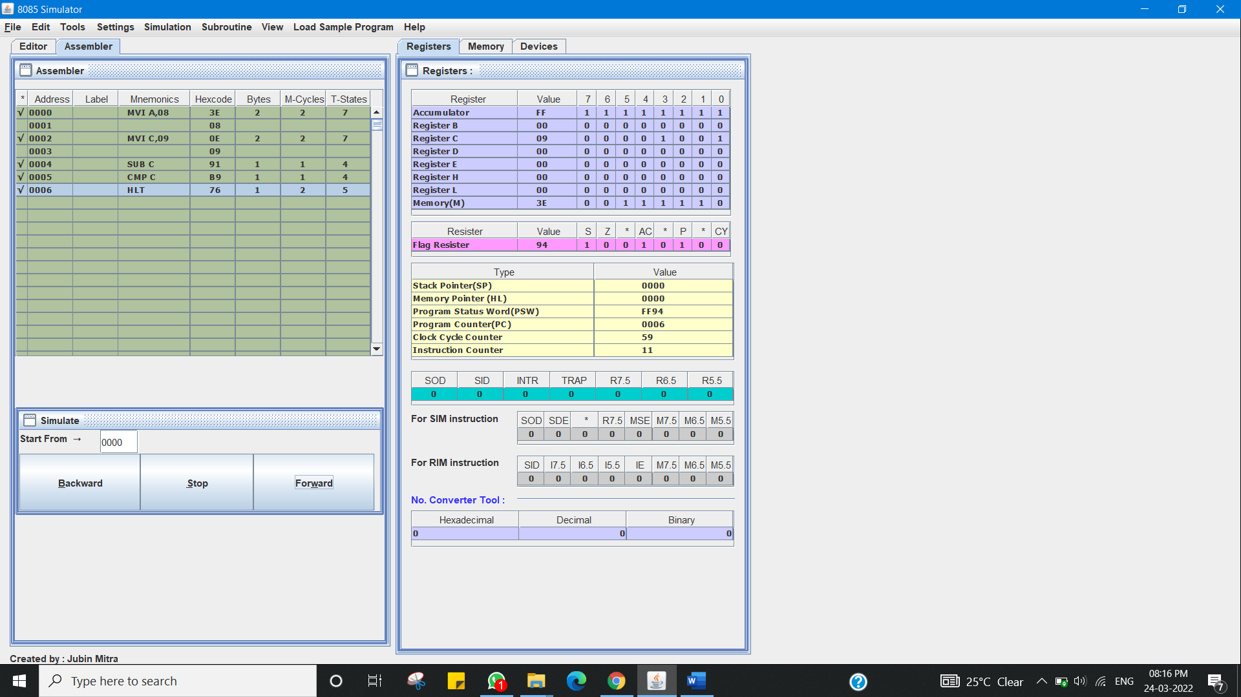

**Evaluation Grid (To be created as per the SOP and Assessment guidelines by the faculty):**

|  |  |  |  |
| --- | --- | --- | --- |
| Sr. No. | Parameters | Marks Obtained | Maximum Marks |
| 1. |  |  |  |
| 2. |  |  |  |
| 3. |  |  |  |
|  |  |  |  |